PHU QUI DANG

Project: DATA VISUALISATION USING TABLEAU

Q1: The manager is searching for a skilled forward player to join the team. Generate visualisation(s) that rank forward players based on the average number of goals they scored and highlight the top 5 players with the highest average number of goals. Your visualisation(s) should enable users to access player attributes, including weight, height, and DOB, by hovering over the players of interest.

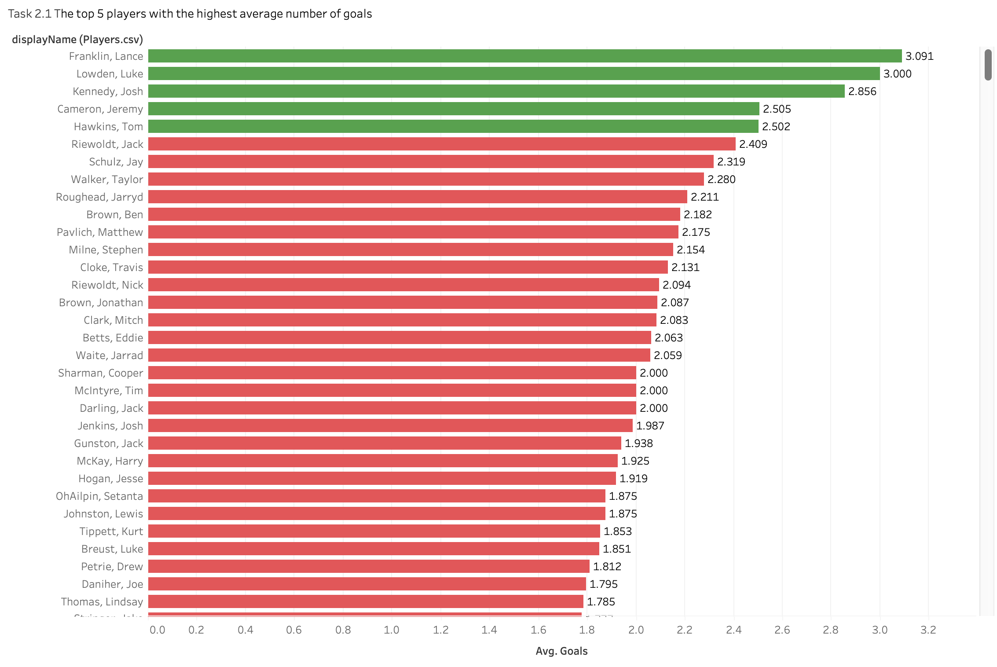

The bar chart shows the top 5 football players based on their average goal-scoring performance, identifying critical prospects for recruitment into forward positions. Each player is ranked in descending order format, making it straightforward to discern the elite performers from the broader dataset. Lance Franklin leads the chart with a remarkable average of 3.091 goals per game, distinctly highlighted in green to emphasise his standout capabilities. Luke Lowden and Josh Kennedy follow him, with impressive averages of 3.000 and 2.856 goals per game. This visual distinction helps quickly identify the top scorer while also drawing attention to the following four leading players, who are integral in understanding the depth of talent available for recruitment. Interactive tooltips, which provide additional data on each player's physical attributes, such as height, weight, and date of birth, enrich the user experience. These tooltips allow team management to gain a comprehensive understanding of not just the players' goal-scoring abilities but also their physical profiles, which are crucial for assessing their overall fitness and suitability for specific team strategies.

Q2: The manager is also keen on understanding how forward players’ age influences their game performance. Create visualisations to show the (average and total) number of goals forward players scored at each age segment in which they scored the goals.

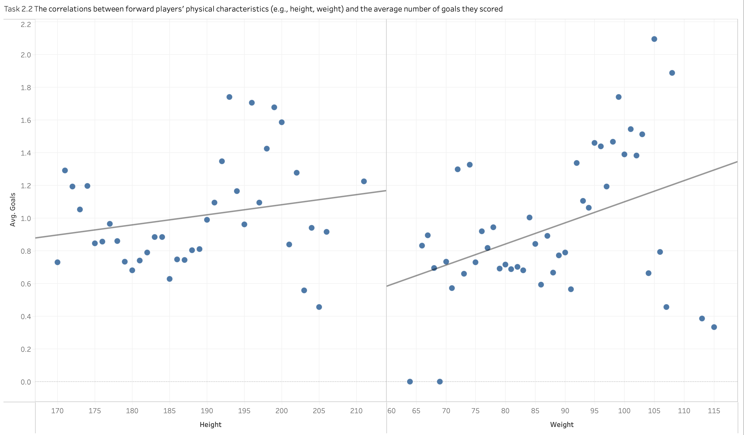

Scatter plot analysis effectively explores the relationship between the physical characteristics of forwards—height and weight, to be precise—and their average scoring performance in football. The plot shows a positive correlation between a player's weight and the average number of goals scored, suggesting that heavier players are more successful in scoring. Each data point represents an individual player, and including a trend line helps visually summarise the overall direction of the relationship, showing that as weight increases, so does scoring probability. This visualisation is a tool for team management, highlighting the potential advantage of players integrated solid physical performance. The chart is enhanced with interactive features, allowing users to hover over data points to retrieve additional information about each player, such as exact height and weight, thereby providing a more comprehensive understanding of how specific physical characteristics can influence athletic success.

Q3: The manager is also keen on understanding how forward players’ age influences their game performance. Create visualisations to show the (average and total) number of goals forward players scored at each age segment in which they scored the goals.

These two bar charts effectively illustrate the relationship between player age and (average and total) goal-scoring performance in football, revealing insightful trends about player productivity across different life stages. The visualisation distinctly compares the average number of goals scored per player with the total goals scored within each age group, using purple to represent averages and red for totals. It highlights that younger players, particularly those aged 19, while not the highest in total goals, achieve a commendable average scoring rate. Additionally, players aged in the range of 38 to 43 have the best average goal-scoring. In contrast, players aged 30 to 35, precisely those aged 33, dominate in total goals scored, suggesting a peak in performance that combines experience with physical capability. The chart provides a straightforward visual narrative that management can utilise to tailor training and recruitment strategies, focusing on nurturing young talent while leveraging the peak performance years of older players.

Q4: Construct a Tableau dashboard to be used by the manager for potential recruitment. Your dashboard should enable the manager to (1) rank forward players based on the average number of goals they scored and highlight the top 5 players with the highest average number of goals, (2) filter players by their team and age, (3) compare height, weight and age of selected forward player(s), and (4) review game performance (focusing on Goals, Goal Assists, and Marks) of selected player(s) over the years.

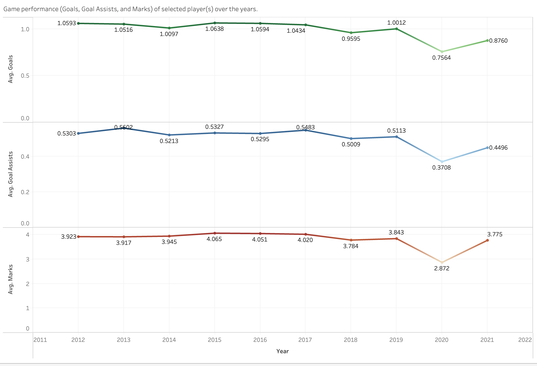

These line charts provide a comprehensive look at the Match performance trends of the selected player(s) over the years, focusing on three key metrics: average goals, assists and points per year. The visualisation shows that all three charts have similar volatility over the years. The average goals chart 2019 shows improved scoring efficiency with the highest index (1.0012). Goal assist figures also show variation, peaking in 2017 and showing a slight downward trend after that. Notably, the index, which peaked in 2019 (3,843), saw volatility fall sharply in 2020 and grow again in 2021, suggesting a possible strategy change or performance recovery of players. Each metric is colour-coded for clarity— goals in blue, assists in green, and marks in red—enhancing the visualisation's usability for strategic analysis. This chart is a tool for team managers to evaluate long-term performance patterns and make informed decisions about player training focus, game strategy adjustments, and transactions or acquisitions of Potential players based on proven strengths and weaknesses over a long period.

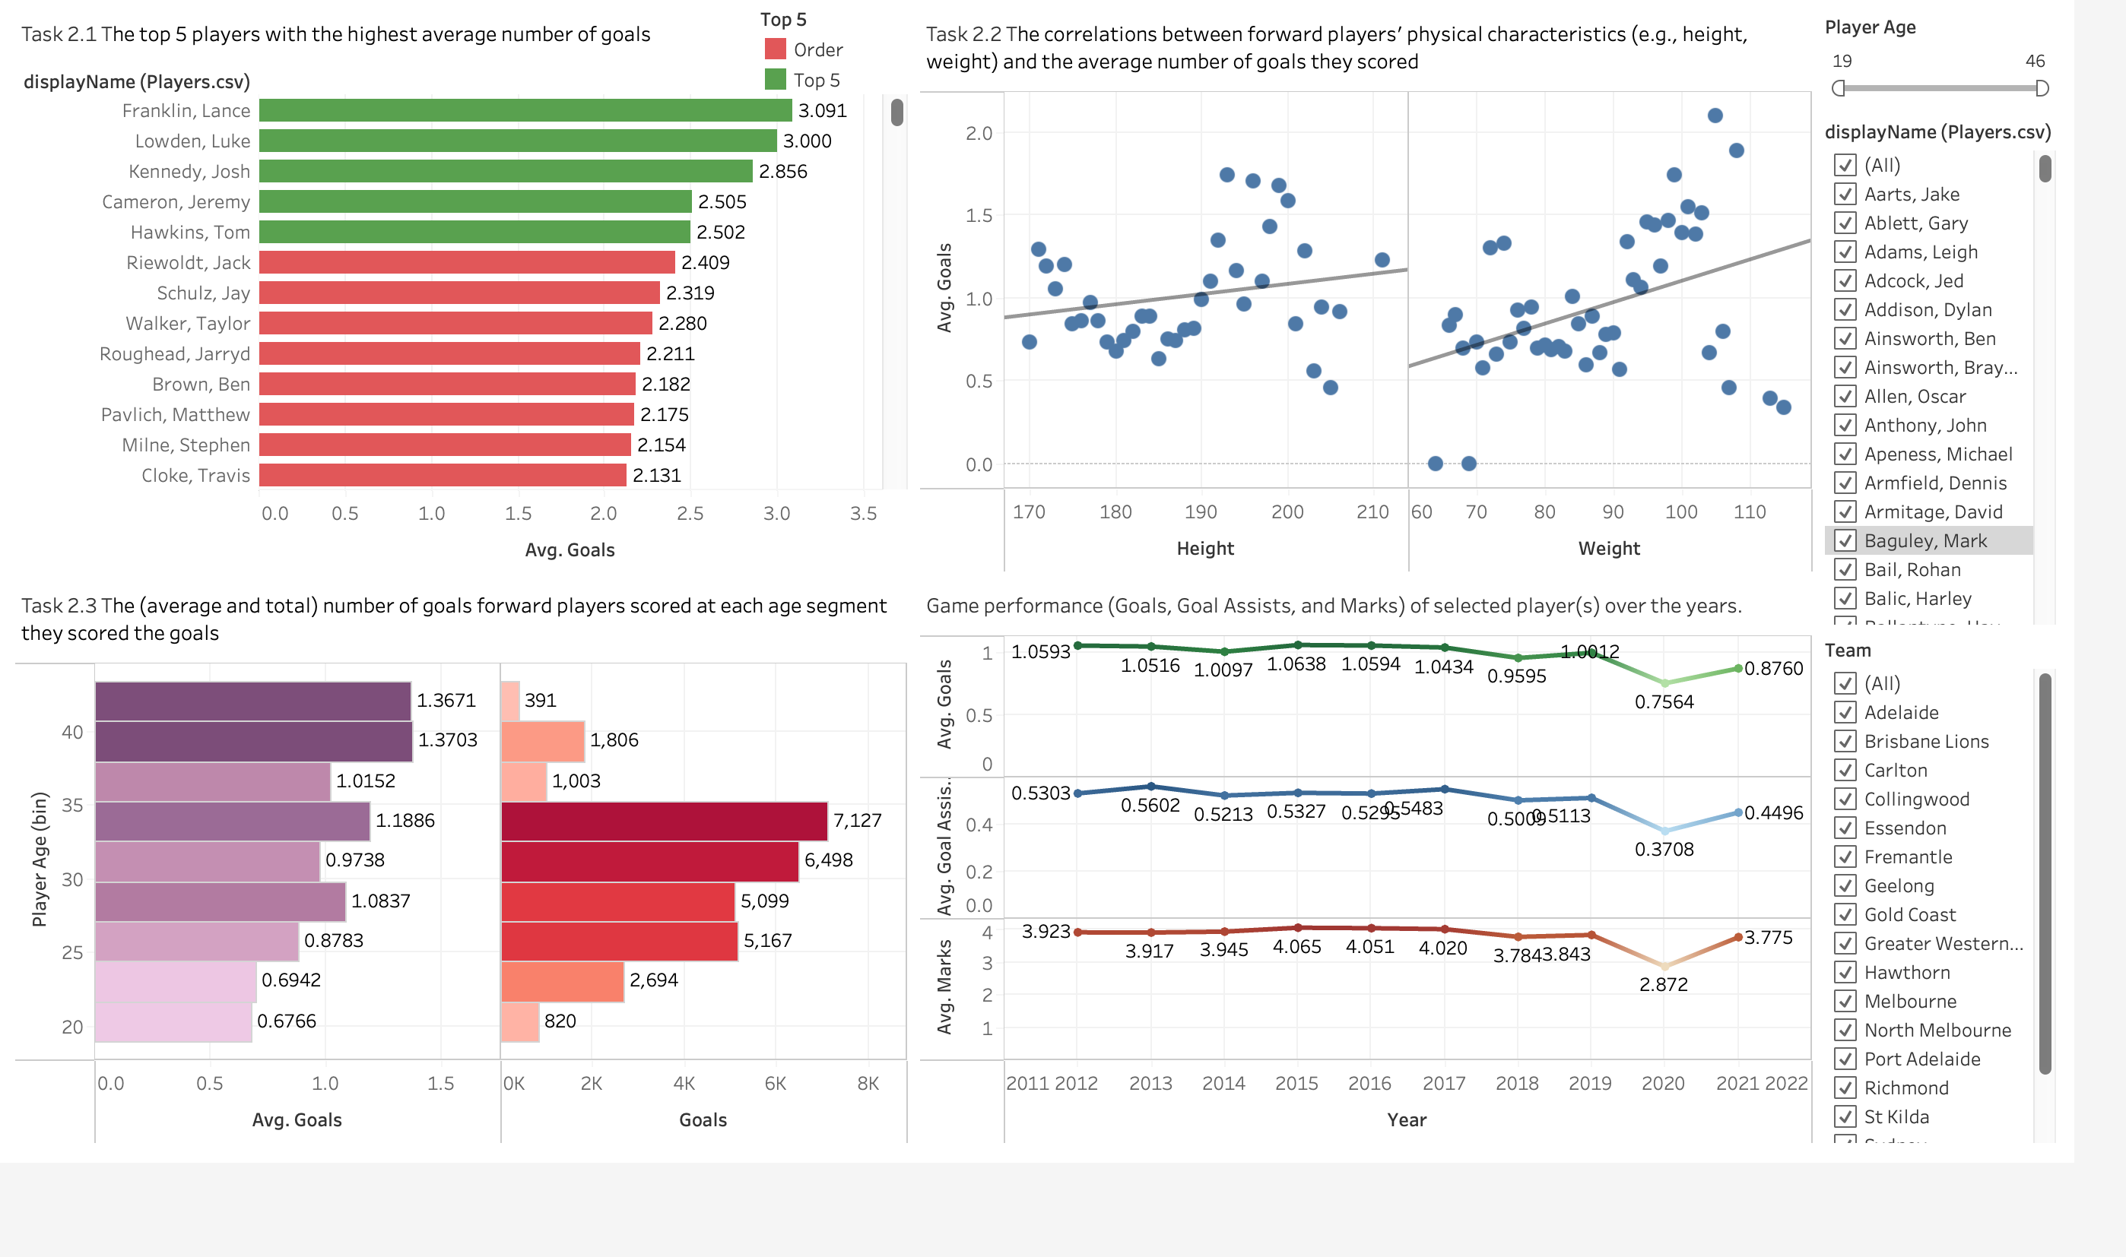

Task 2's visualisations provide essential insights into player performance in rugby. Task 1 identifies the players who score the most goals, identifying key players such as Lance Franklin to focus on recruiting. Task 2 correlates players' weight and goals, suggesting heavier players score more effectively. Task 3 reveals age-related trends, highlighting the peak performance of players in their late twenties. Finally, multi-year trend analysis of Mission 2.4 through line graphs tracks fluctuations in goals, assists and goals over a decade, providing strategic insights into performance trends and recovery from downturns, which are essential for long-term team building and strategic player development. These visualisations offer comprehensive tools to enhance team strategy and optimise player utilisation.